# Simple DevOps project for CI/CD | CI/CD through Jenkins and Tomcat

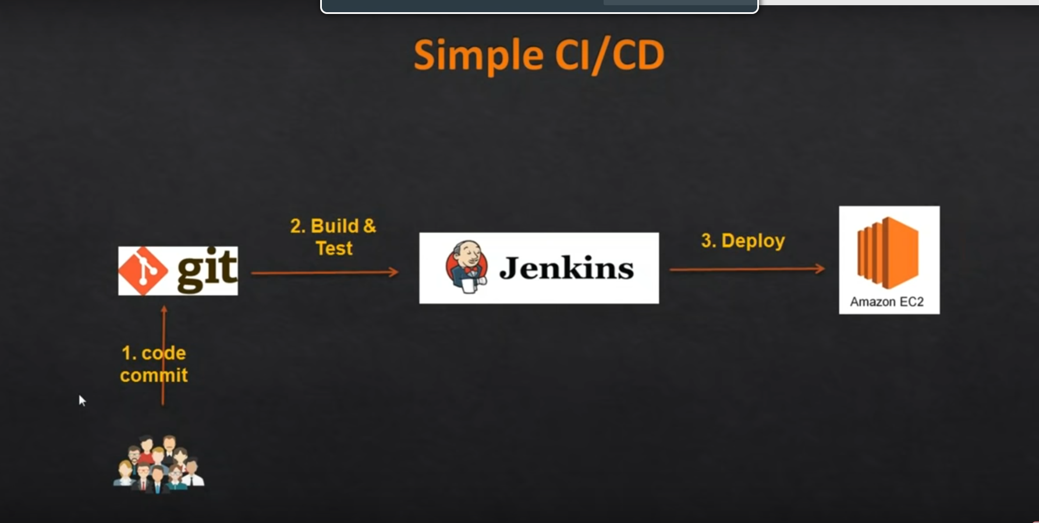

**Following Two Steps –**

1. **Tomcat installation on EC2 instance.**
2. **Install Jenkins on AWS EC2**

**Tomcat installation on EC2 instance**

Step-1: Provision EC2 Machine.

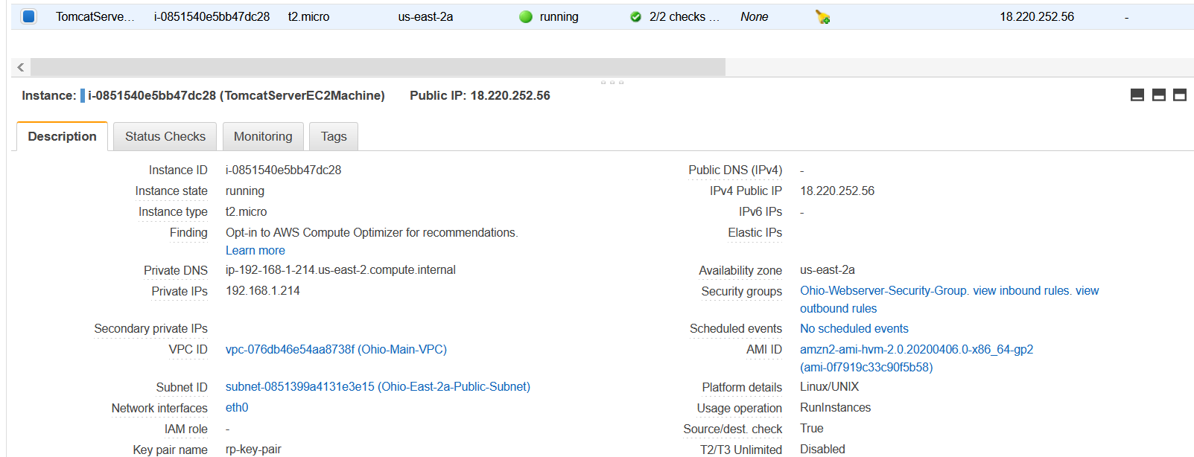

Step-2: Connect and Login EC2 Tomcat Server Machine and run below command to install tomcat.

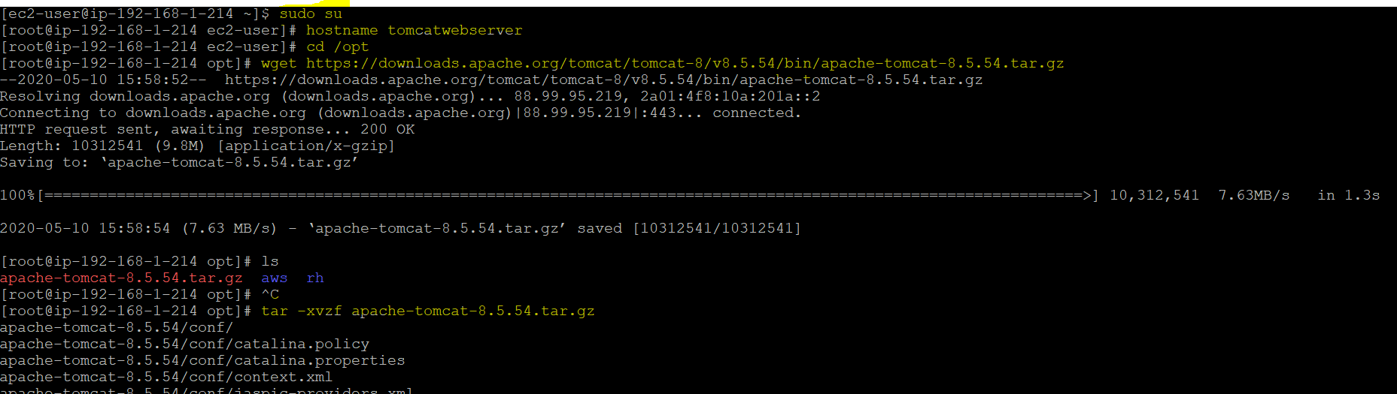

**Install Java if Not on installed**

1. We will be using open java for our demo, Get the latest version from <http://openjdk.java.net/install/>
2. yum install java-1.8*

#yum -y install java-1.8.0-openjdk-devel

1. Confirm Java Version and set the java home
2. java -version
3. find /usr/lib/jvm/java-1.8* | head -n 3
4. JAVA_HOME=/usr/lib/jvm/java-1.8.0-openjdk-<Java version which seen in the above output>
5. export JAVA_HOME
6. PATH=$PATH:$JAVA_HOME
7. # To set it permanently update your .bash_profile

vi ~/.bash_profile



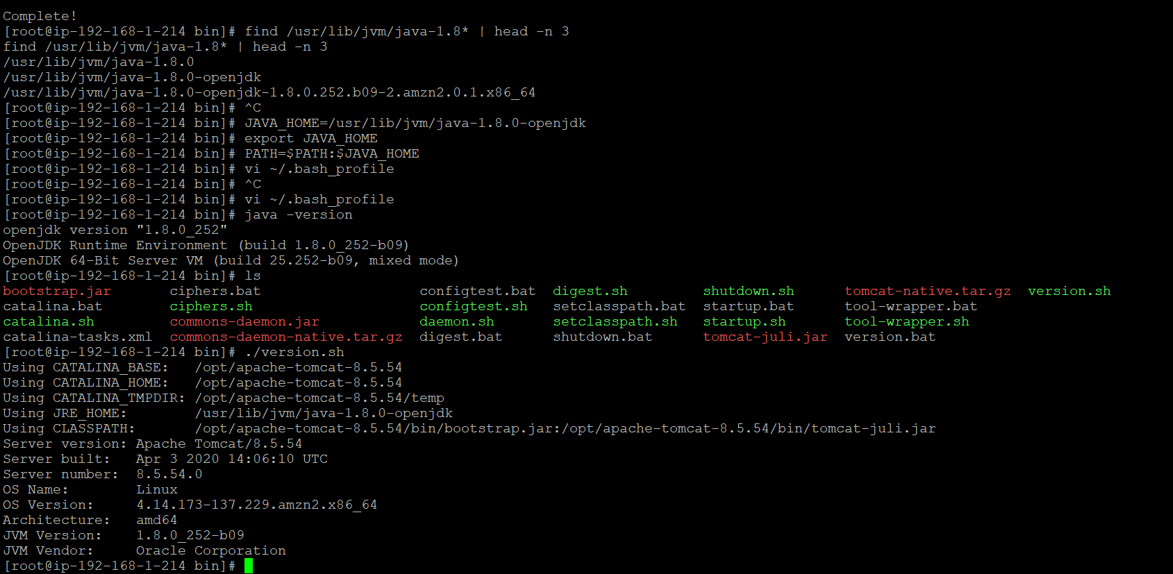

Step-2:Now Run the tomcat

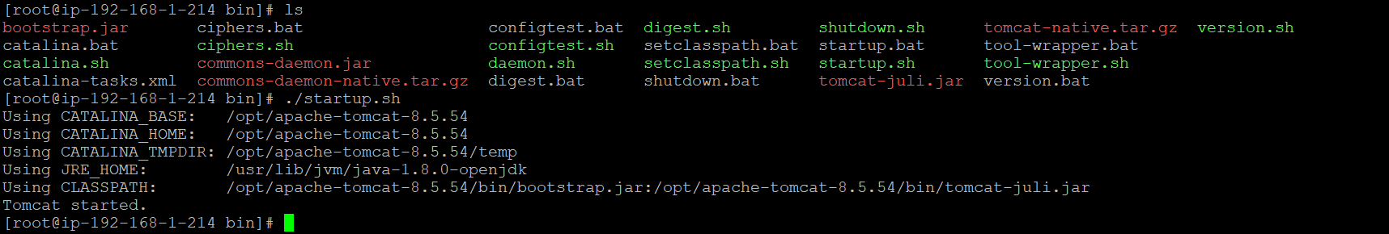

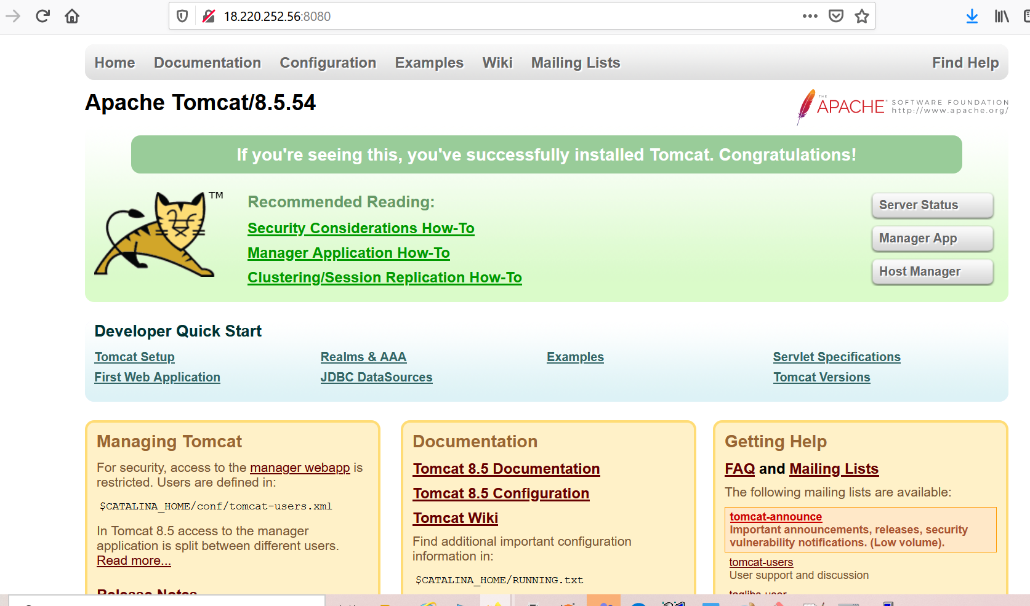

Step-3: Now comment RemoteAddr in Context.xml

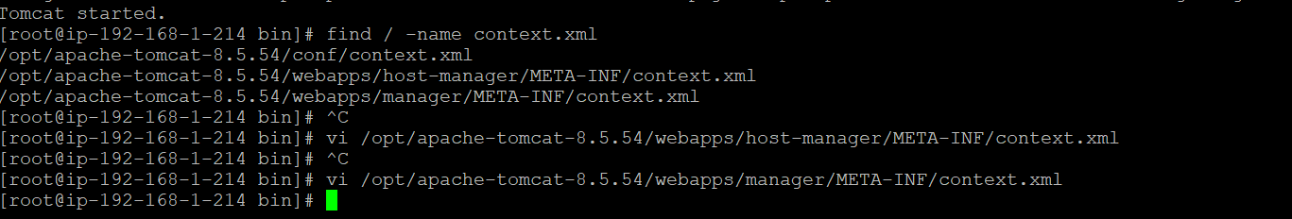

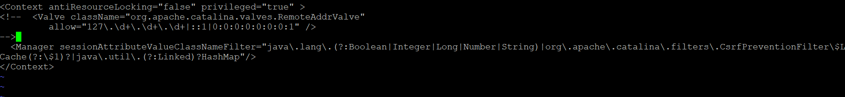

Step-4: Now, Add users and roles ‘**tomcat-users.xml**’

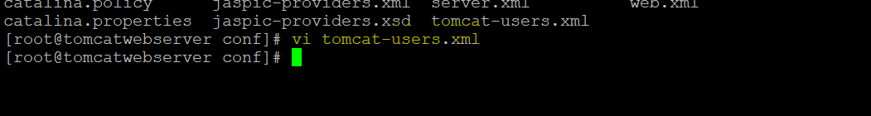

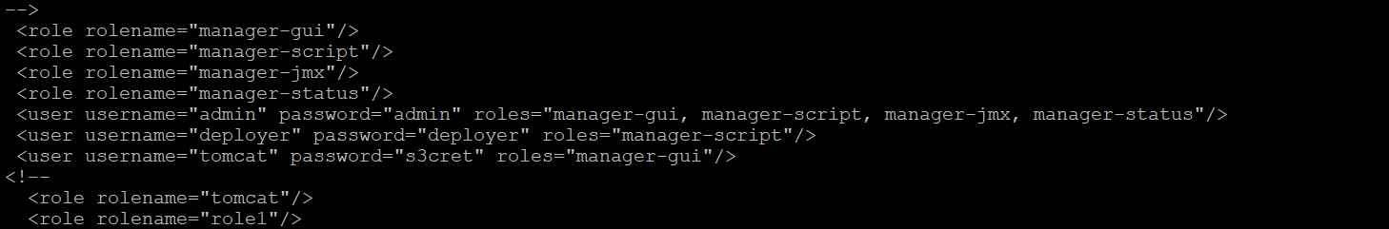

Step-5: Restart the Tomcat Server.

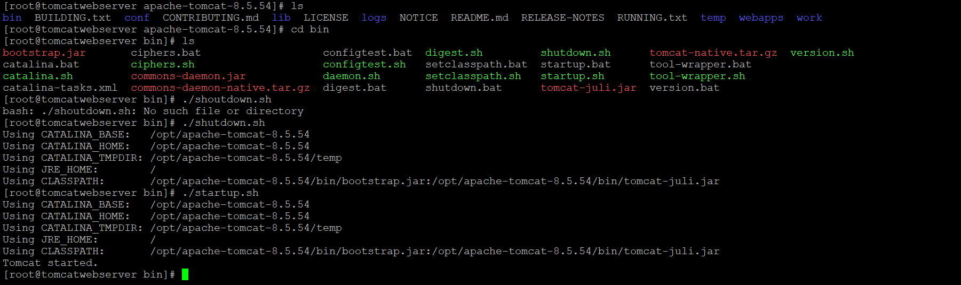

Step-6: Login to Tomcat Console.

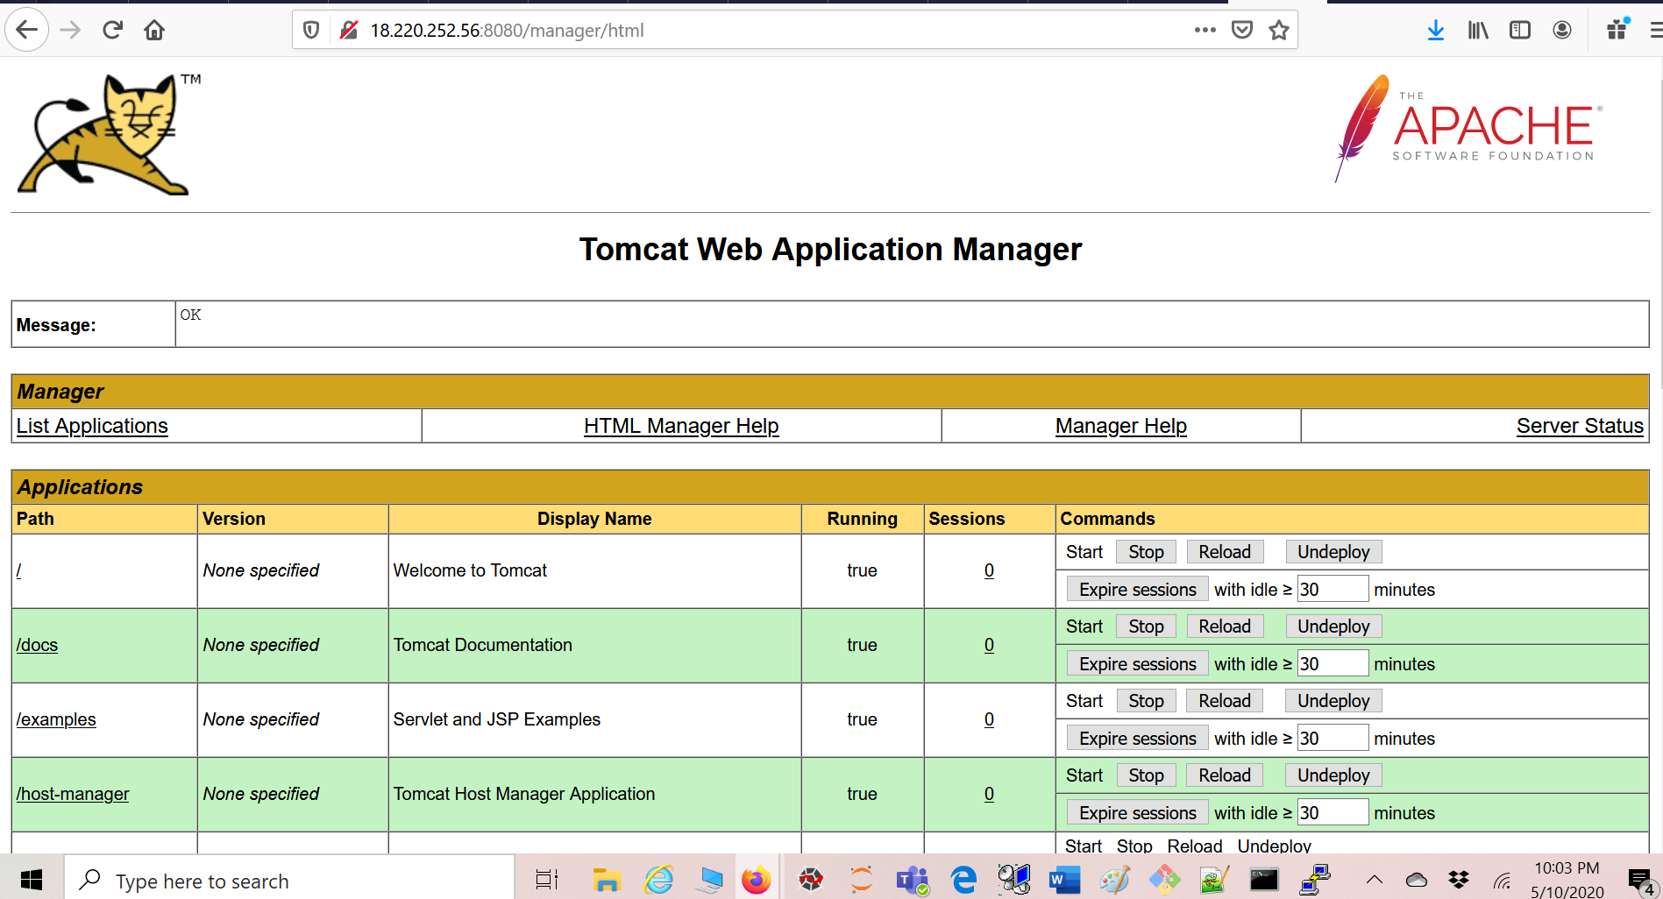

Jenkins is a self-contained Java-based program, ready to run out-of-the-box, with packages for Windows, Mac OS X and other Unix-like operating systems. As an extensible automation server, Jenkins can be used as a simple CI server or turned into the continuous delivery hub for any project.

### Prerequisites

1. EC2 Instance
   * With Internet Access
   * Security Group with Port 8080 open for internet
2. Java v1.8.x

## Install Java

1. We will be using open java for our demo, Get the latest version from <http://openjdk.java.net/install/>
2. yum install java-1.8*

#yum -y install java-1.8.0-openjdk-devel

1. Confirm Java Version and set the java home
2. java -version
3. find /usr/lib/jvm/java-1.8* | head -n 3
4. JAVA_HOME=/usr/lib/jvm/java-1.8.0-openjdk-<Java version which seen in the above output>
5. export JAVA_HOME
6. PATH=$PATH:$JAVA_HOME
7. # To set it permanently update your .bash_profile

vi ~/.bash_profile

The output should be something like this,

[root@~]# java -version

openjdk version "1.8.0_151"

OpenJDK Runtime Environment (build 1.8.0_151-b12)

OpenJDK 64-Bit Server VM (build 25.151-b12, mixed mode)

## Install Jenkins

You can install jenkins using the rpm or by setting up the repo. We will set up the repo so that we can update it easily in the future.

1. Get the latest version of jenkins from <https://pkg.jenkins.io/redhat-stable/> and install
2. yum -y install wget
3. sudo wget -O /etc/yum.repos.d/jenkins.repo https://pkg.jenkins.io/redhat-stable/jenkins.repo
4. sudo rpm --import https://pkg.jenkins.io/redhat-stable/jenkins.io.key

yum -y install jenkins

### Start Jenkins

# Start jenkins service

service jenkins start

# Setup Jenkins to start at boot,

chkconfig jenkins on

### Accessing Jenkins

By default jenkins runs at port 8080, You can access jenkins at

http://YOUR-SERVER-PUBLIC-IP:8080

#### Configure Jenkins

* The default Username is admin
* Grab the default password
* Password Location:/var/lib/jenkins/secrets/initialAdminPassword
* Skip Plugin Installation; We can do it later
* Change admin password
  + Admin > Configure > Password
* Configure java path
  + Manage Jenkins > Global Tool Configuration > JDK
* Create another admin user id

### Test Jenkins Jobs

1. Create “new item”
2. Enter an item name – My-First-Project
   * Chose Freestyle project
3. Under the Build section Execute shell: echo "Welcome to Jenkins Demo"
4. Save your job
5. Build job
6. Check "console output"

Step-1: Install Java

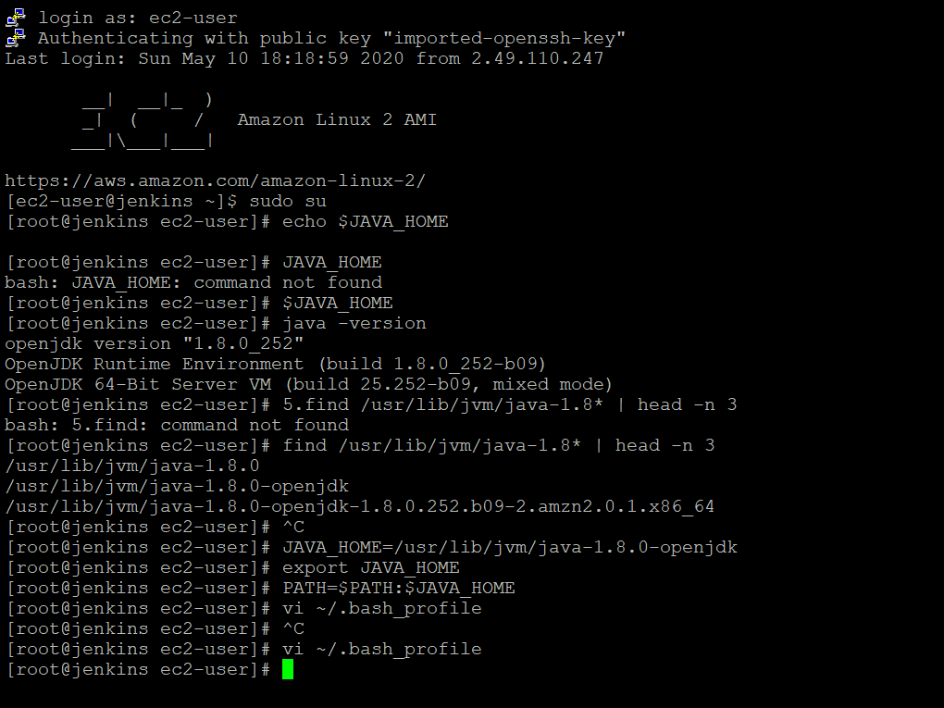

Step-2: Install Jenkins

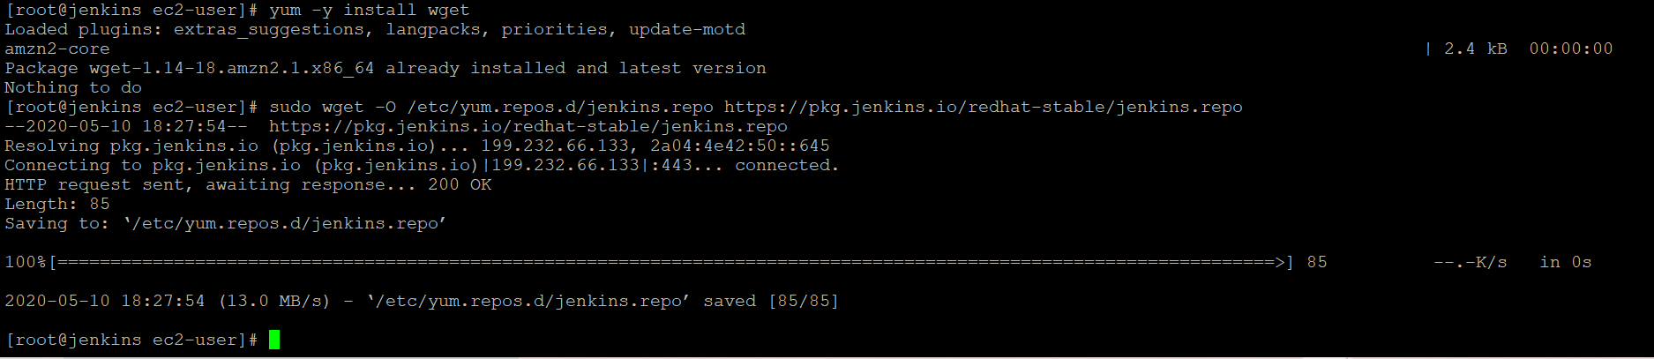

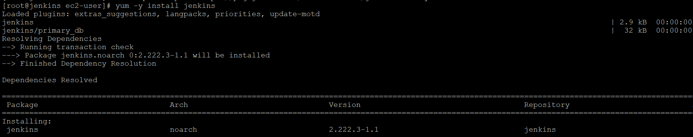

Step-3: Run Jenkins



Step-4: Login to Jenkins and set password.



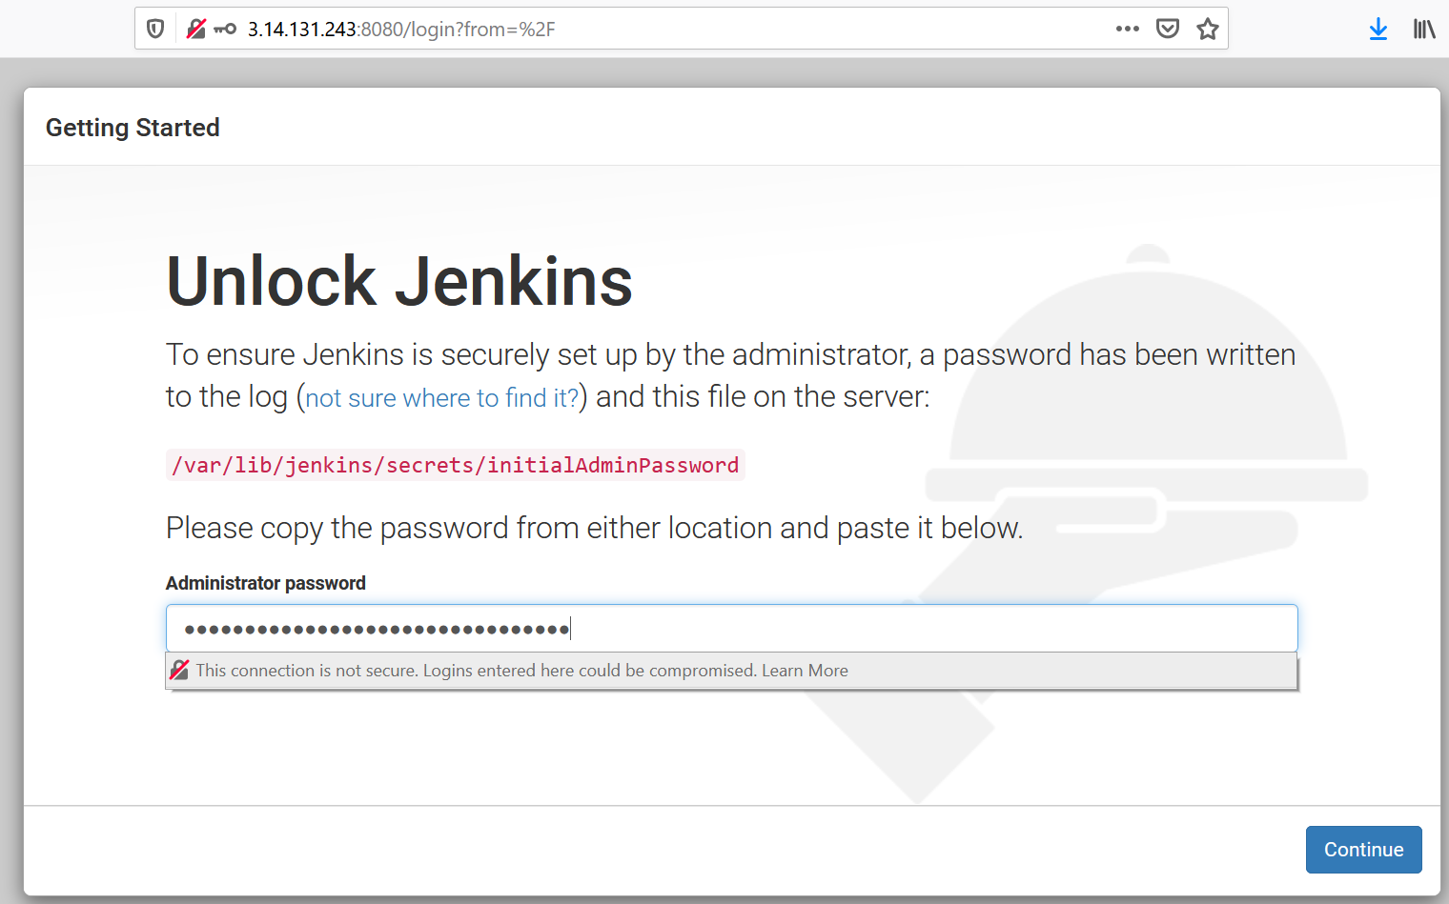

Step-5: Set admin password

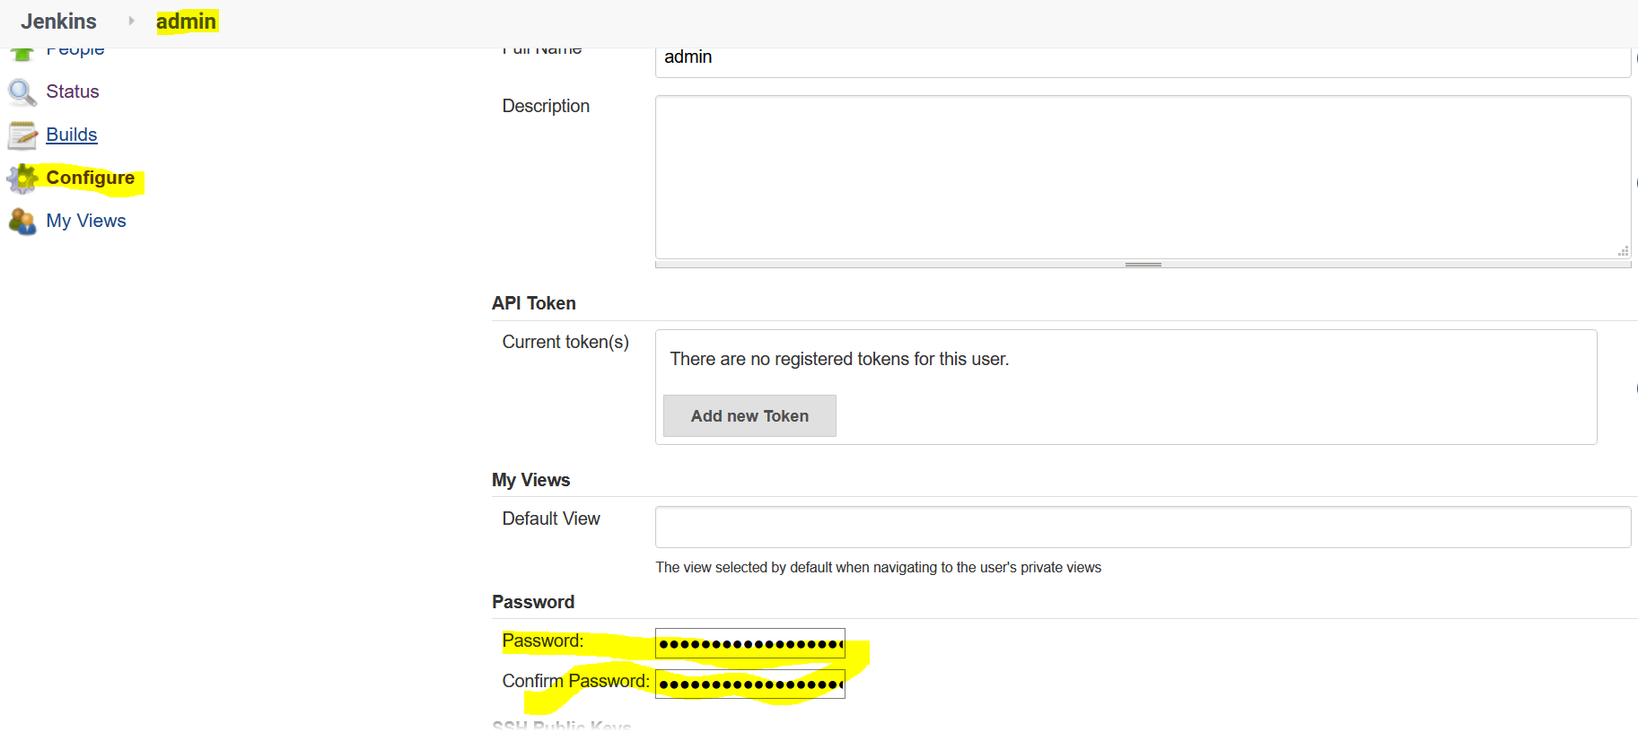

Step-6: Configure java path

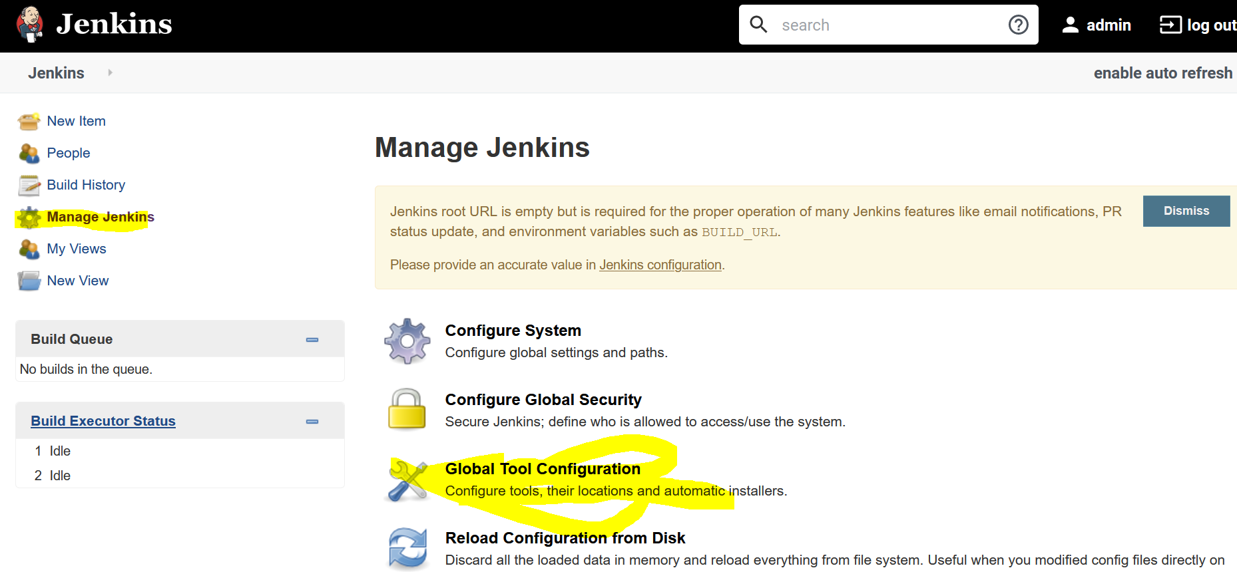

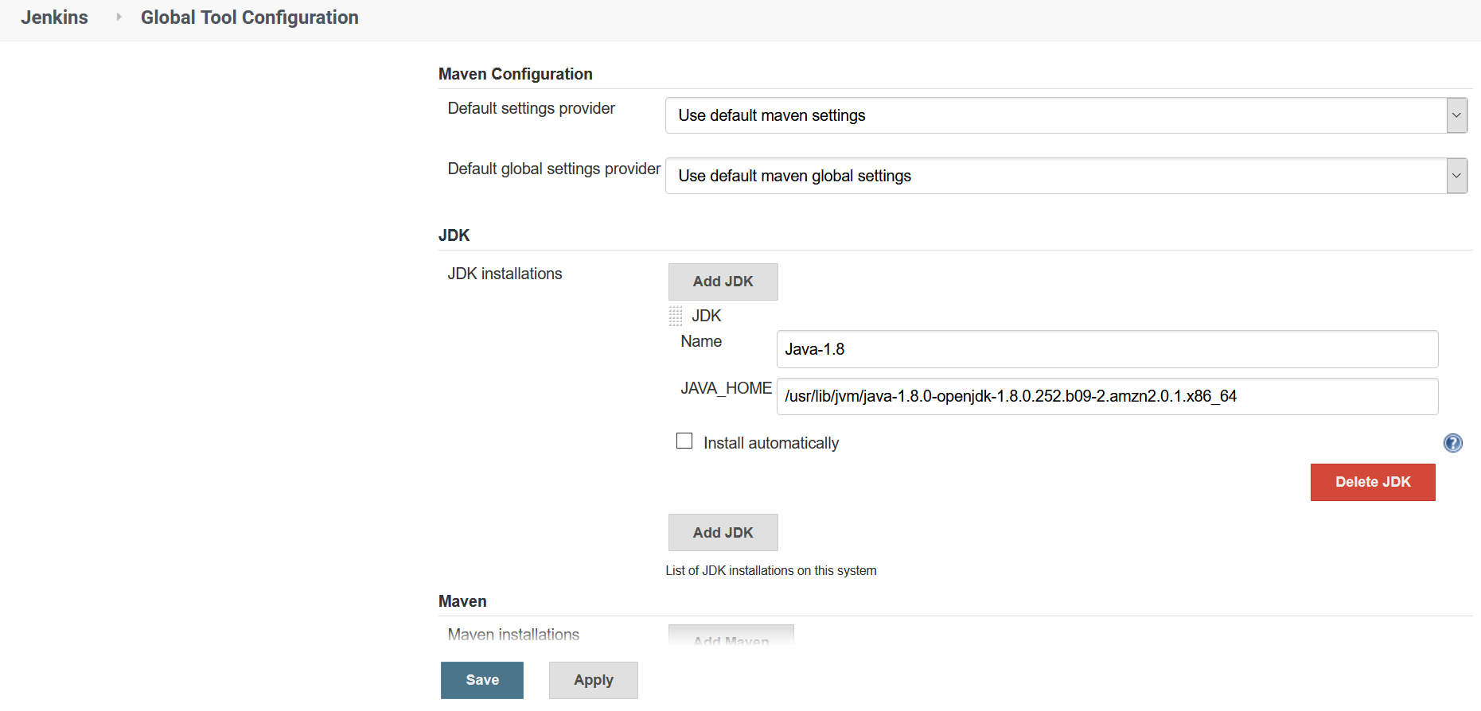

# Configure Git pulgin on Jenkins

s one of the most popular tools for version control system. you can pull code from git repositories using jenkins if you use github plugin.

#### Prerequisites

1. Jenkins server

#### Install Git on Jenkins server

1. Install git packages on jenkins server

yum install git -y

#### Setup Git on jenkins console

* Install git plugin without restart
  + Manage Jenkins > Jenkins Plugins > available > github
* Configure git path
  + Manage Jenkins > Global Tool Configuration > git

Step wise step Screen shot

Install git on Jenkins EC2 Server

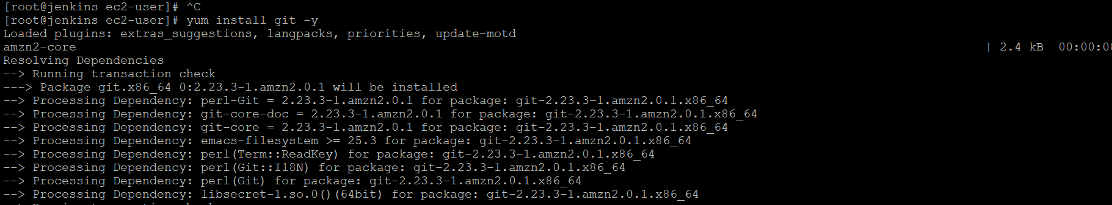

Go To Jenkins Console

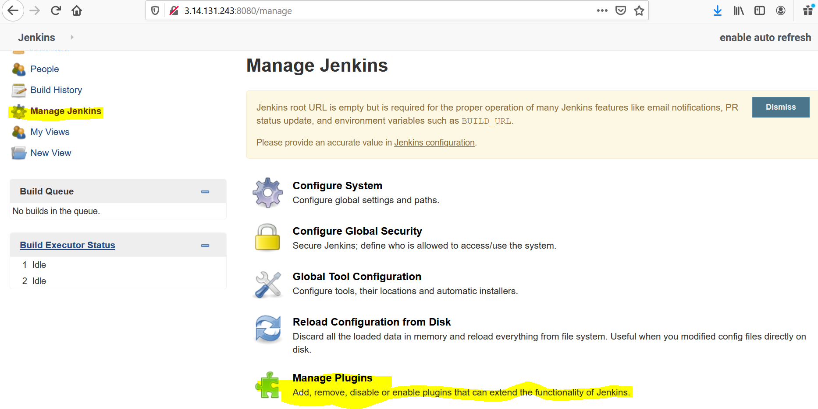

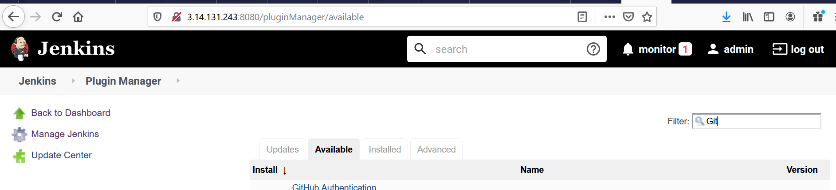

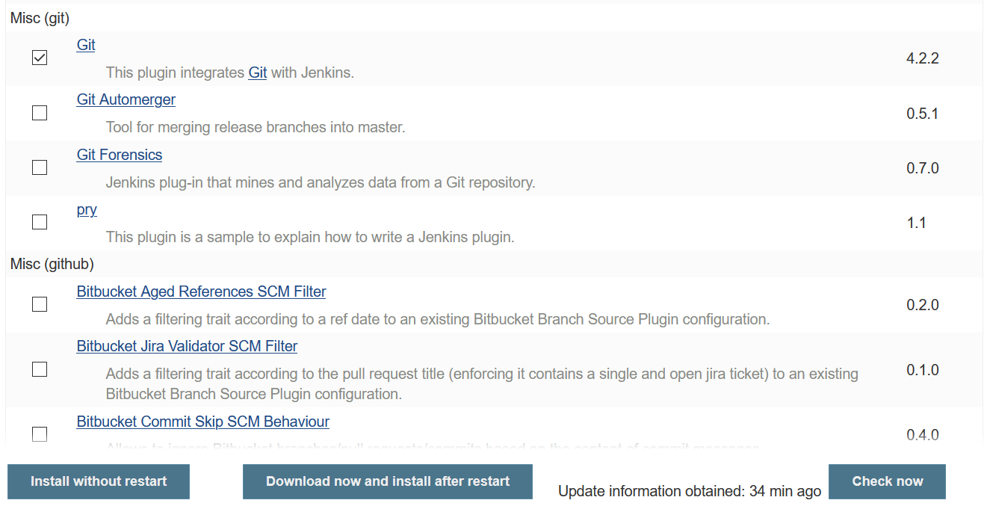

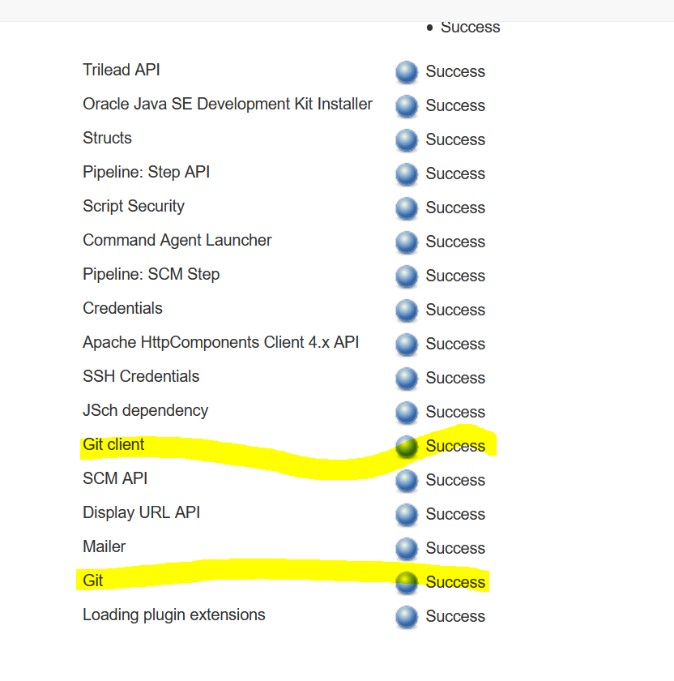

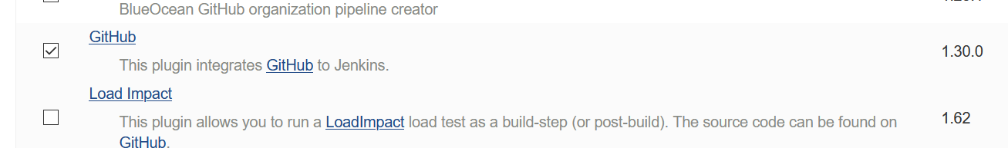

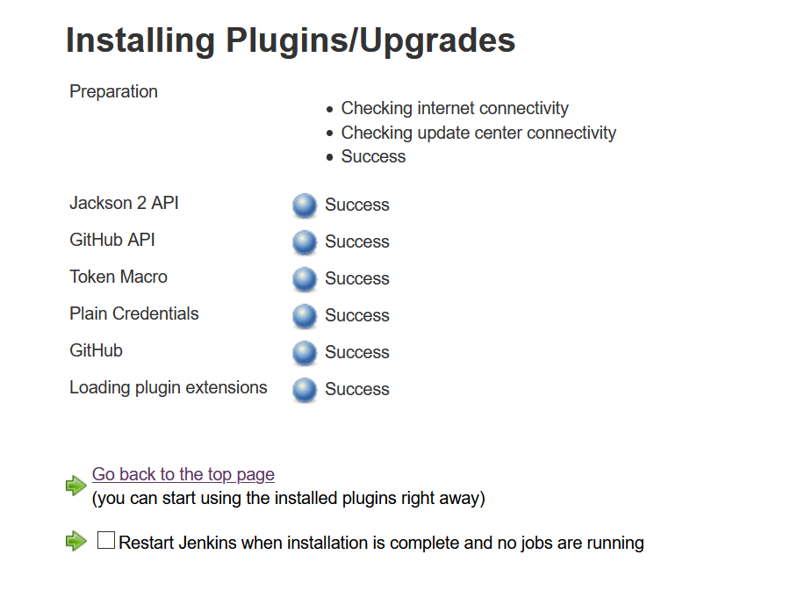

# Install & configure Maven build tool on Jenkins

Maven is a code build tool which used to convert your code to an artifact. this is a widely used plugin to build in continuous integration

#### Prerequisites

1. Jenkins server

#### Install Maven on Jenkins

1. Download maven packages <https://maven.apache.org/download.cgi> onto Jenkins server. In this case, I am using /opt/maven as my installation directory

* Link : <https://maven.apache.org/download.cgi>
* # Creating maven directory under /opt
* mkdir /opt/maven
* cd /opt/maven
* # downloading maven version 3.6.0
* wget http://mirrors.estointernet.in/apache/maven/maven-3/3.6.1/binaries/apache-maven-3.6.1-bin.tar.gz

tar -xvzf apache-maven-3.6.1-bin.tar.gz

1. Setup M2_HOME and M2 paths in .bash_profile of the user and add these to the path variable
2. vi ~/.bash_profile
3. M2_HOME=/opt/maven/apache-maven-3.6.1
4. M2=$M2_HOME/bin

PATH=<Existing_PATH>:$M2_HOME:$M2

#### Checkpoint

1. logoff and login to check maven version

mvn --version

So far we have completed the installation of maven software to support maven plugin on the jenkins console. Let's jump onto Jenkins to complete the remaining steps.

### Setup maven on Jenkins console

1. Install maven plugin without restart

* Manage Jenkins > Jenkins Plugins > available > Maven Invoker
* Manage Jenkins > Jenkins Plugins > available > Maven Integration

1. Configure maven path

* Manage Jenkins > Global Tool Configuration > Maven

Step-1: Download Maven and install

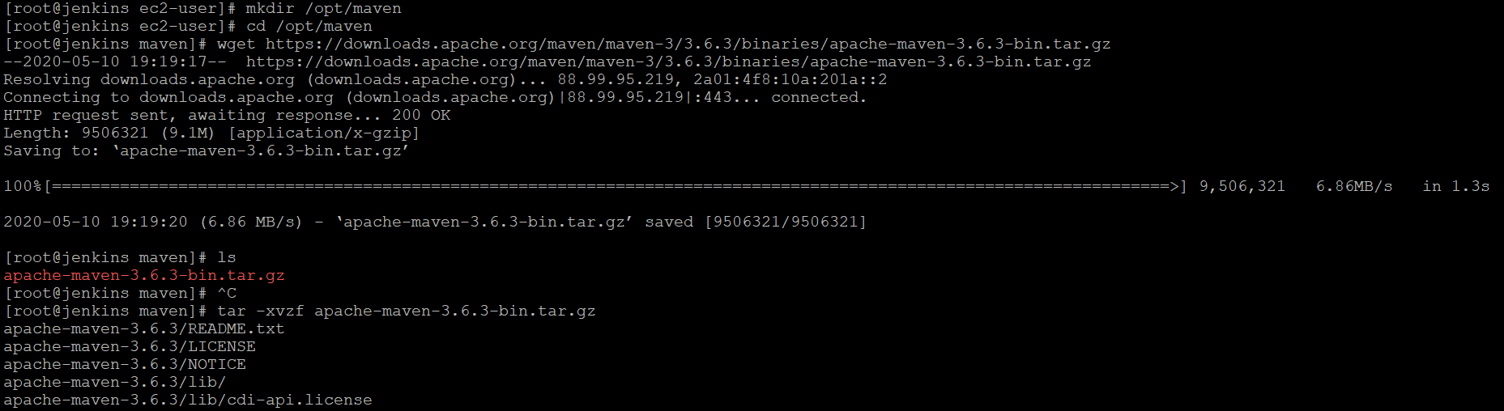

Step-2: Set Path and Maven Home

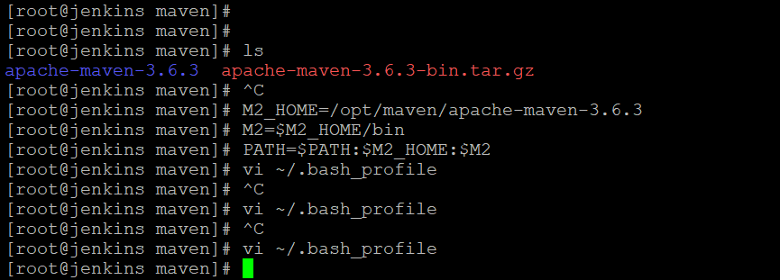

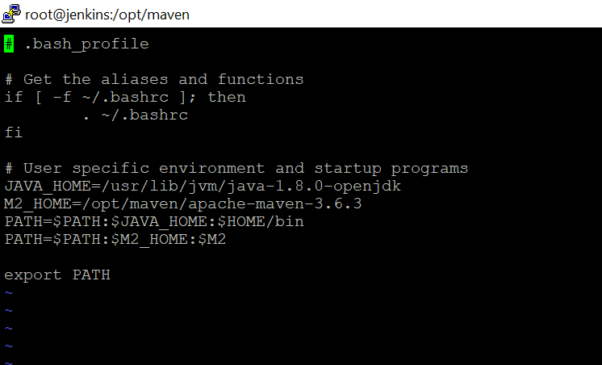

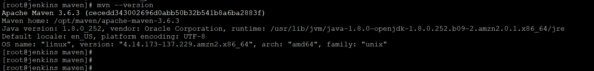

### Step-3: Setup maven on Jenkins console

1. Install maven plugin without restart

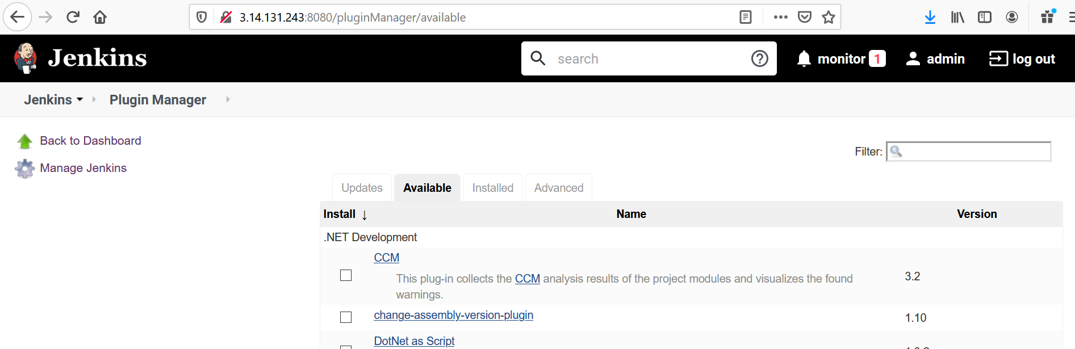

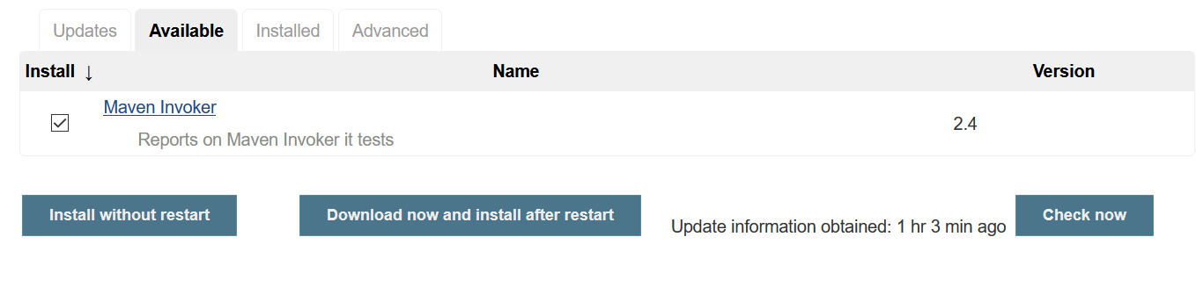

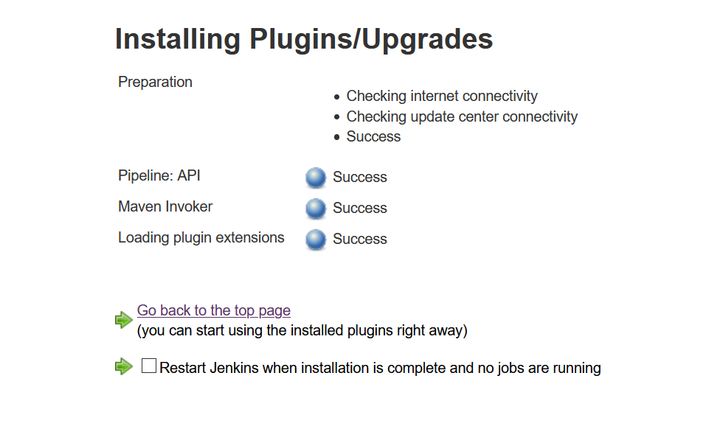

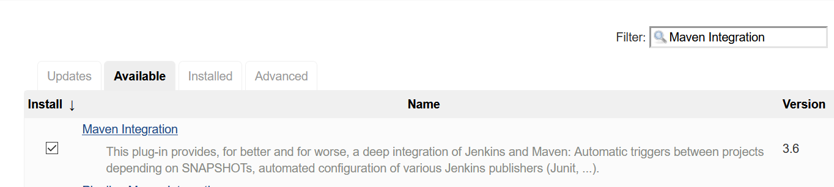

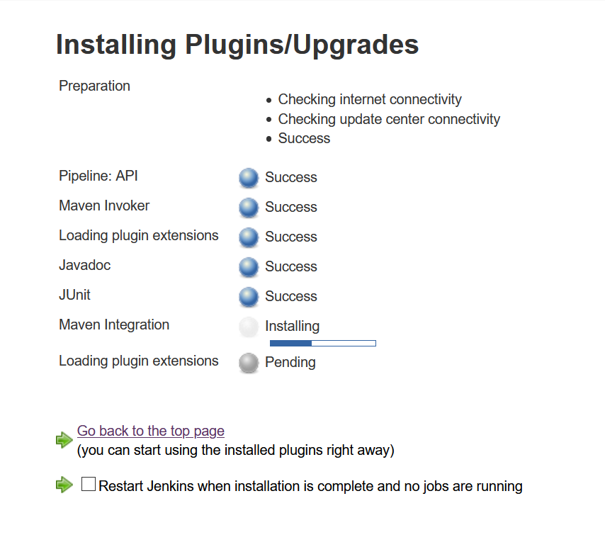

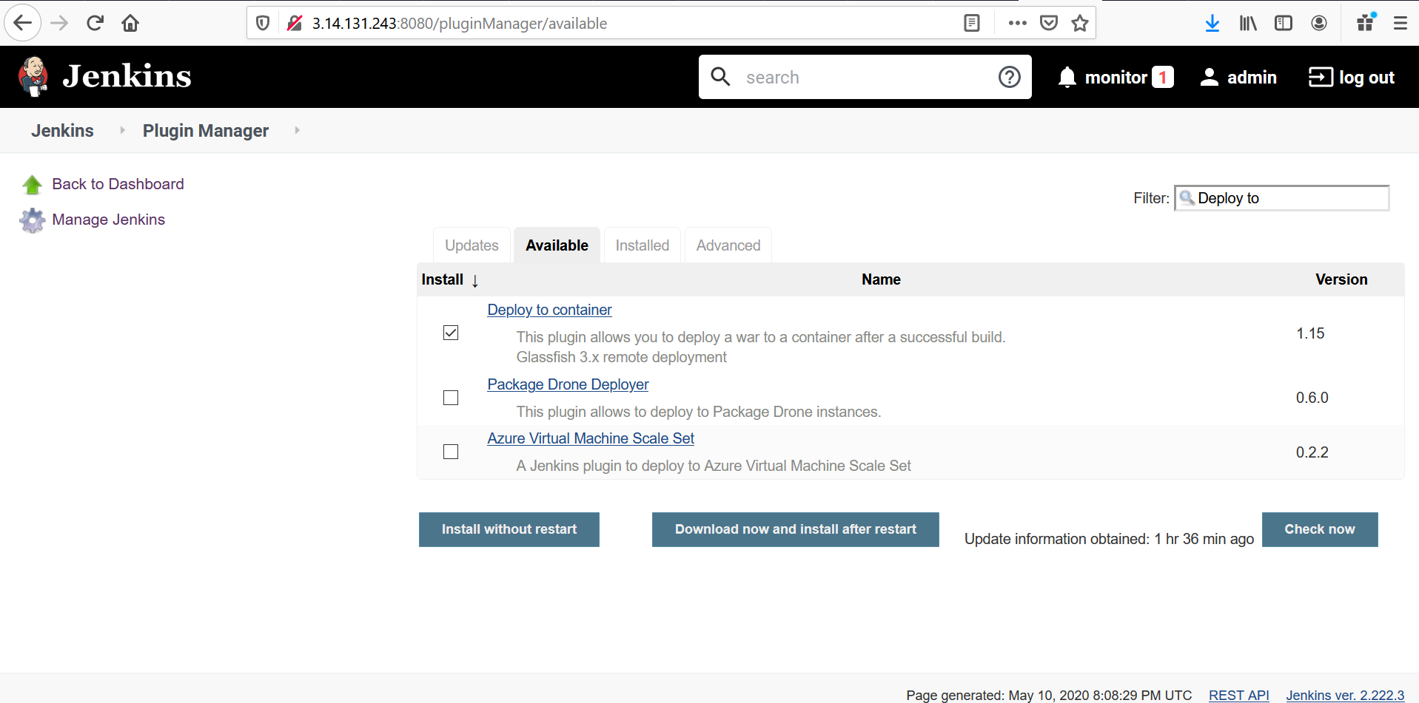

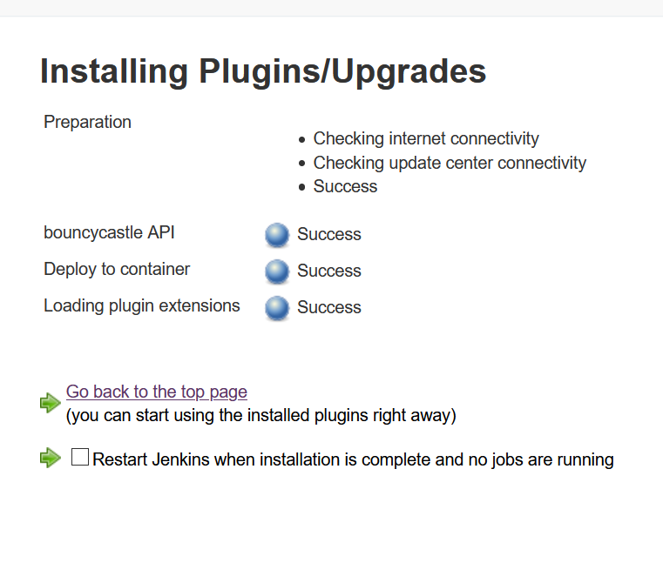

1. Configure maven path

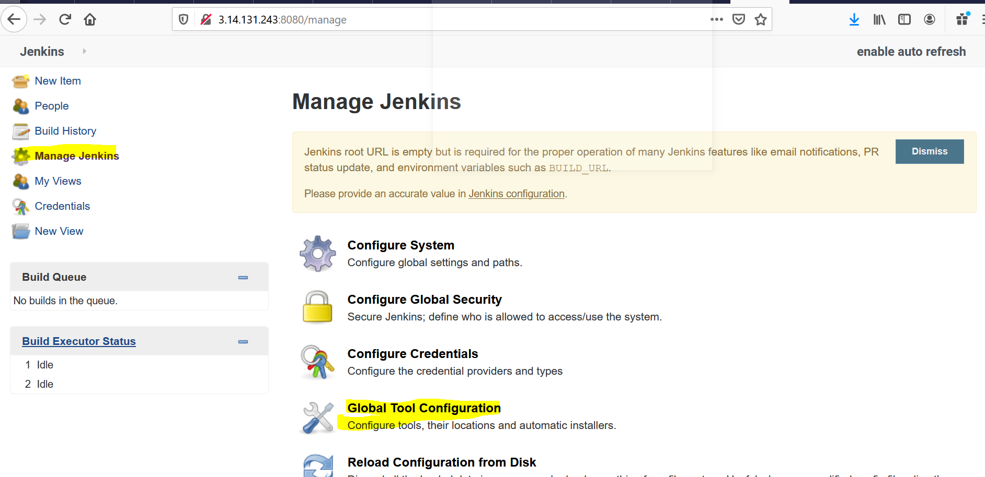

Step-3: Configure Tomcat Credentials.

Go to Tomcat EC2 Server Machine and check tomcat credentials

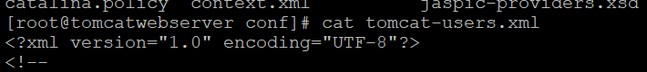

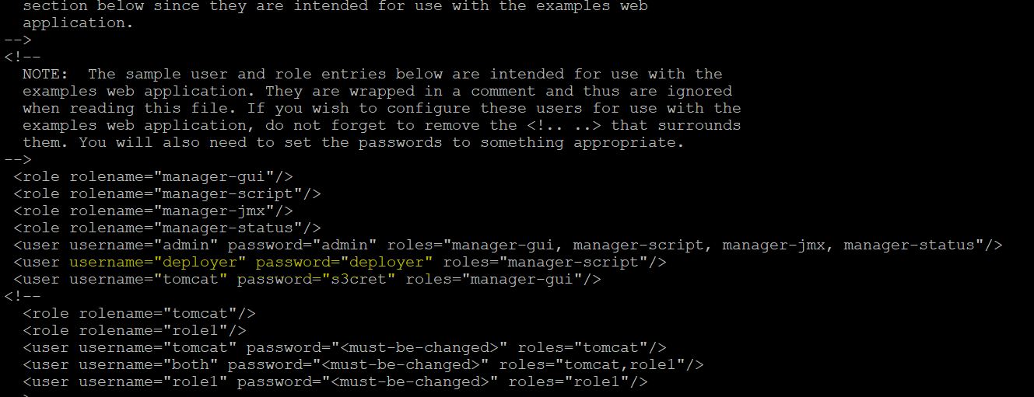

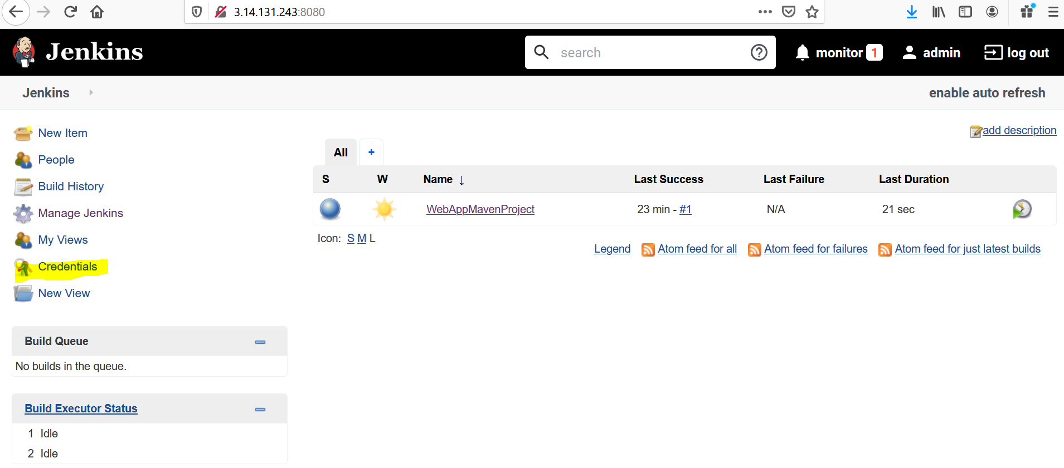

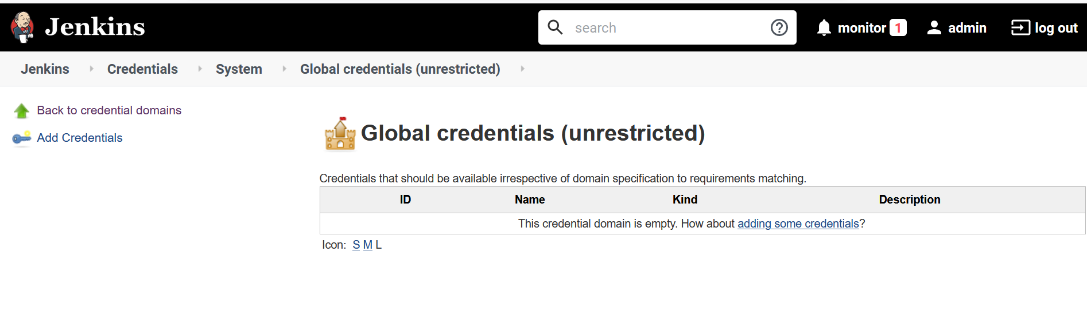

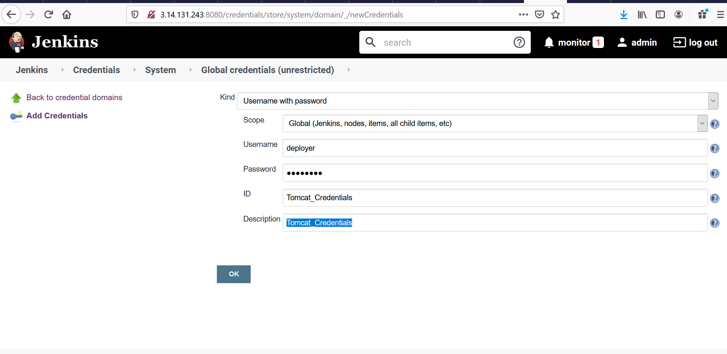

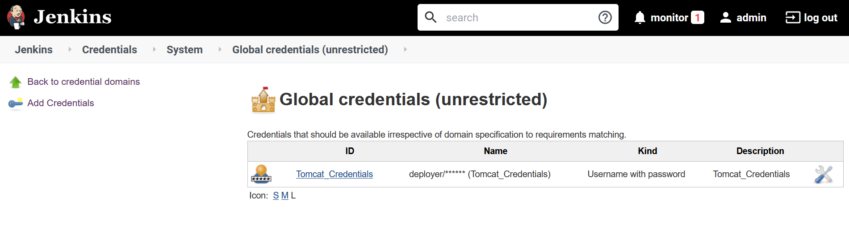

Configure CI/CD using Git using Jenkins and Tomcat

* 1. Create CI/CD job.

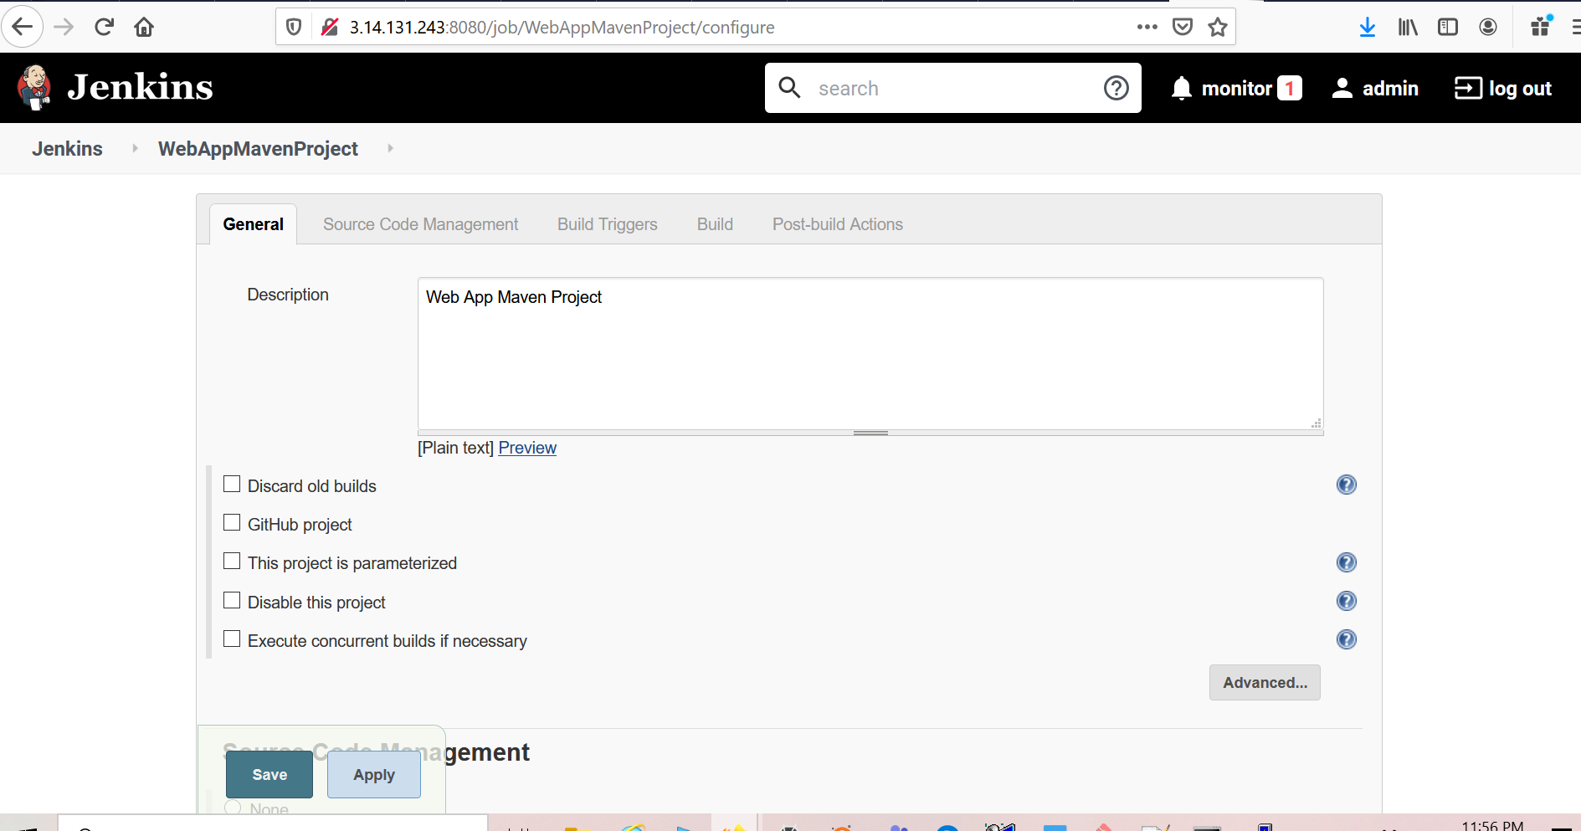

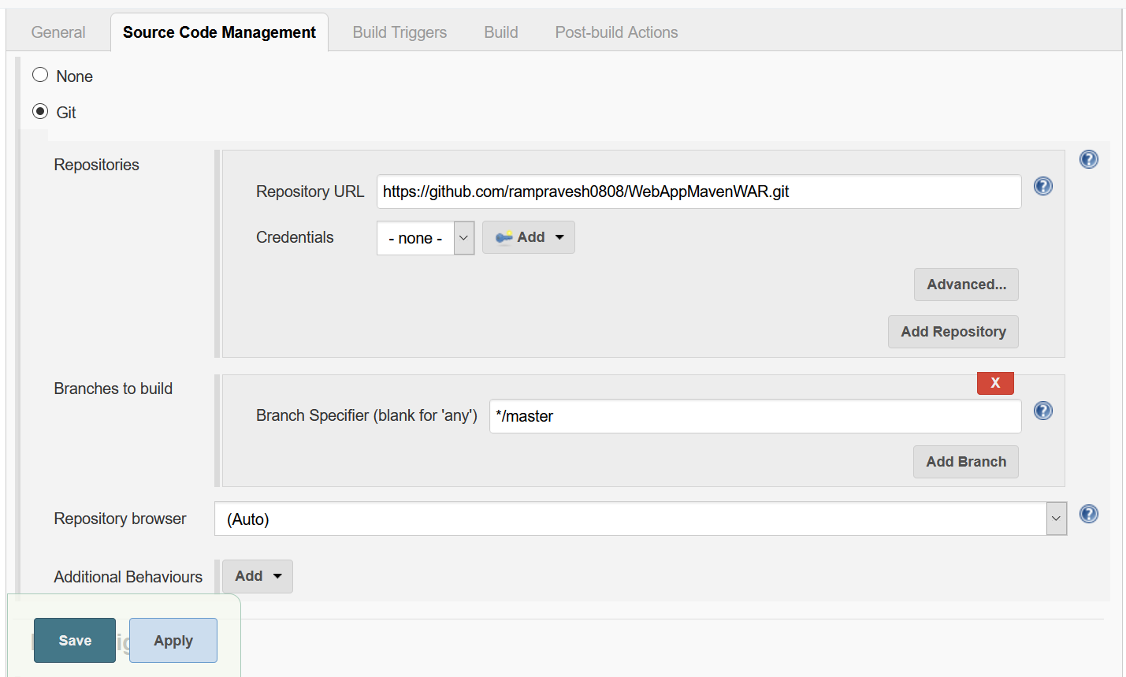

**Continuous Integrations.**

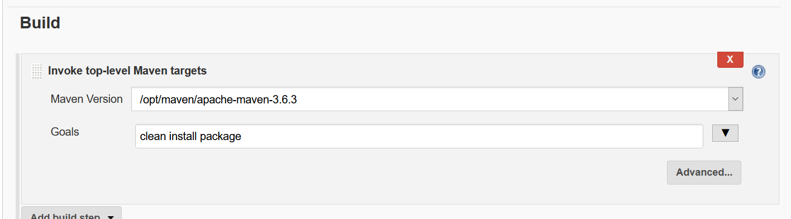

* 1. Run the build.

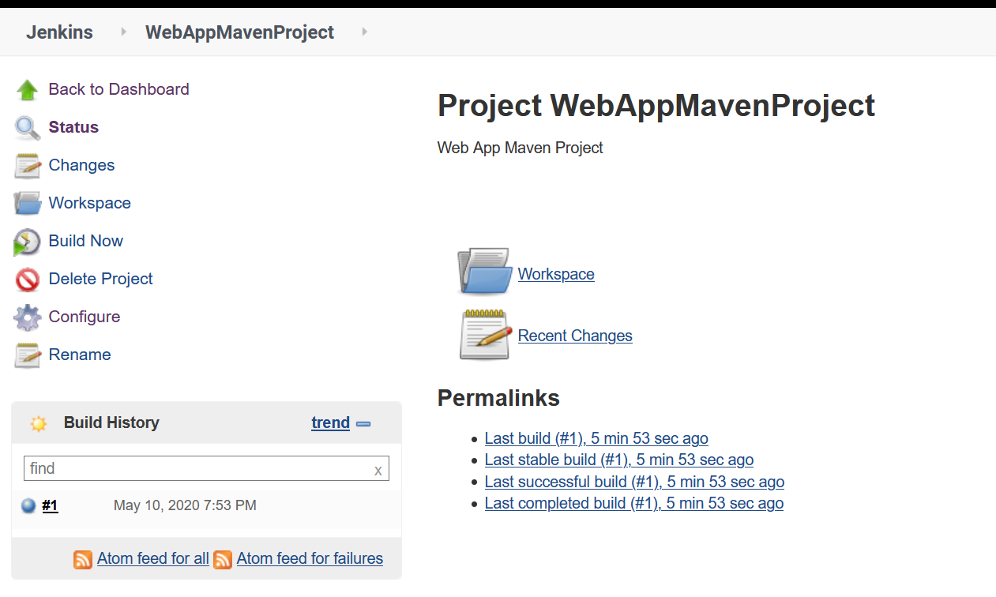

Build successfully and generated WAR file copied at target folder in EC2 Jenkins Machine.

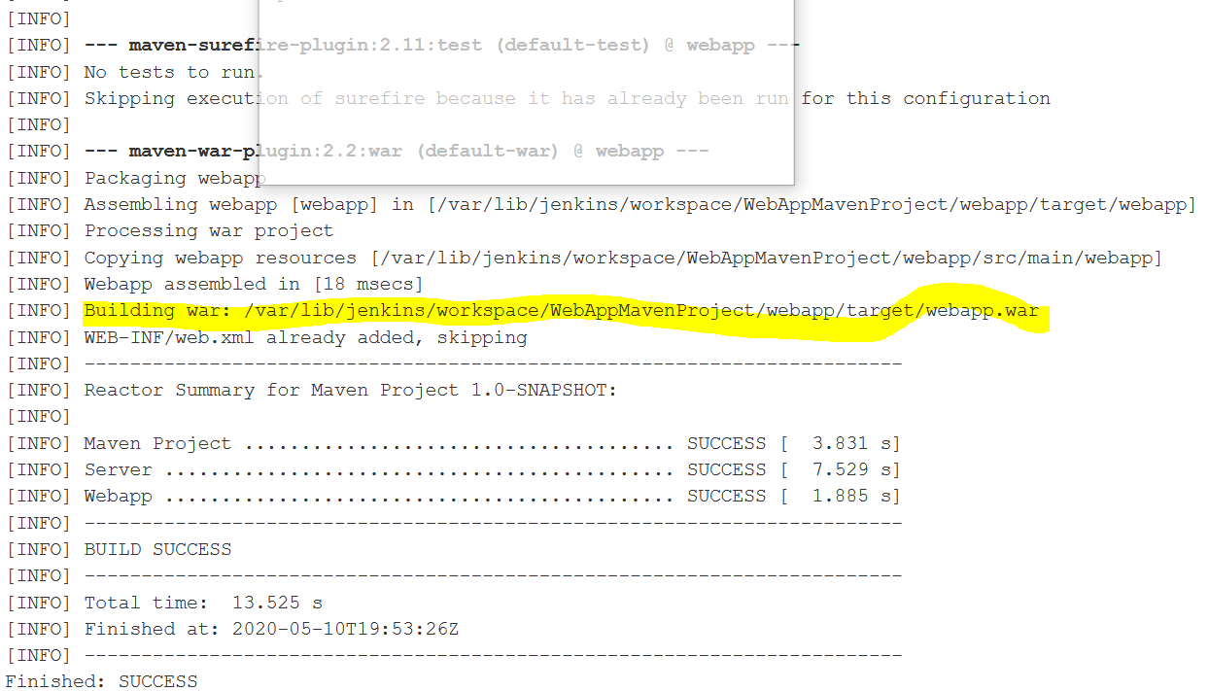

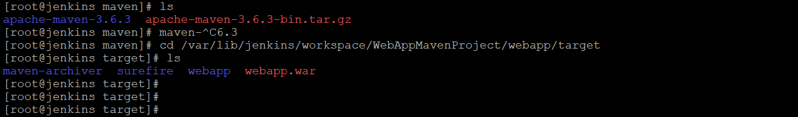

* 1. Configure Continuous Delivery

Install Jenkins Plugin

Go to Jenkins -> Open Job -> Configure

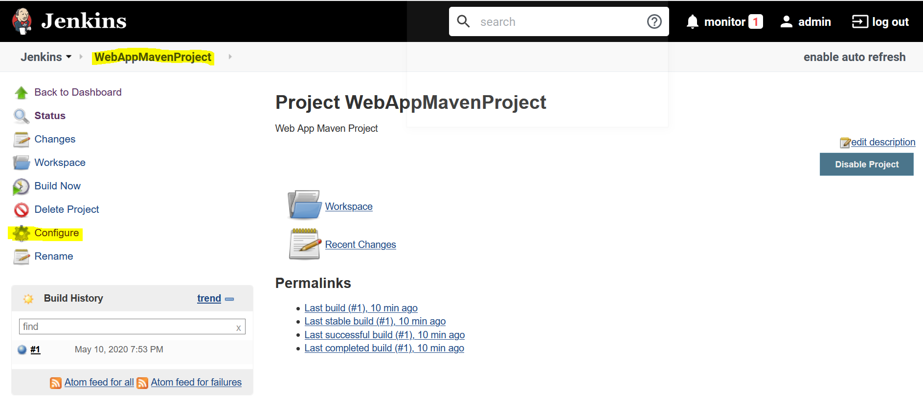

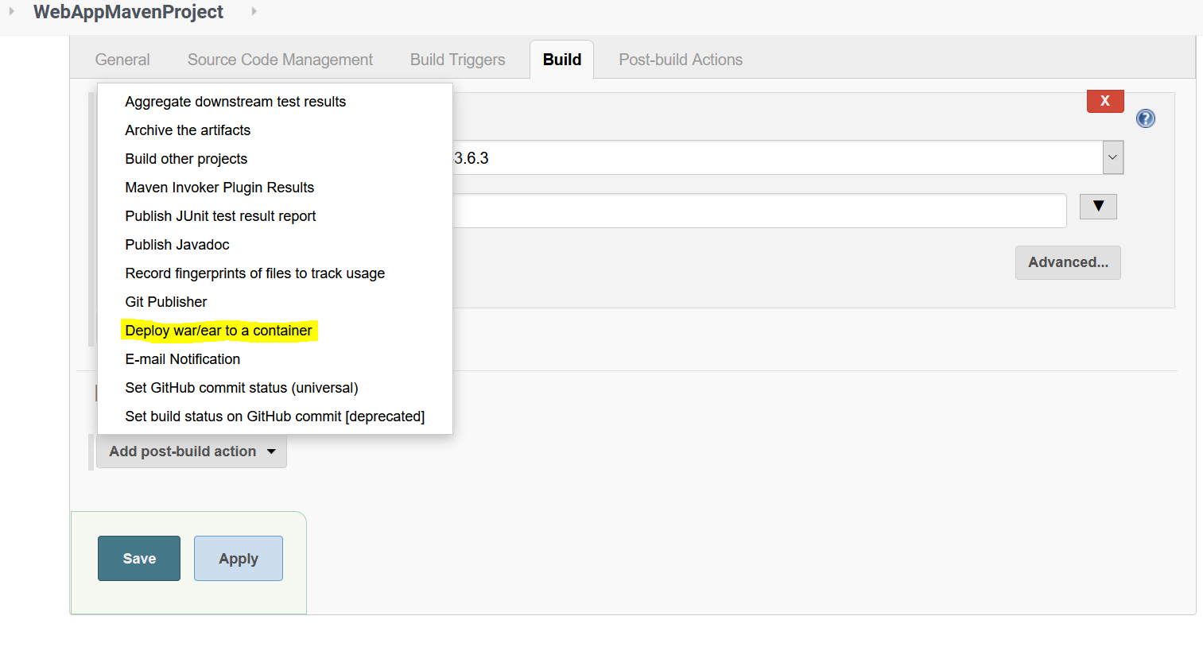

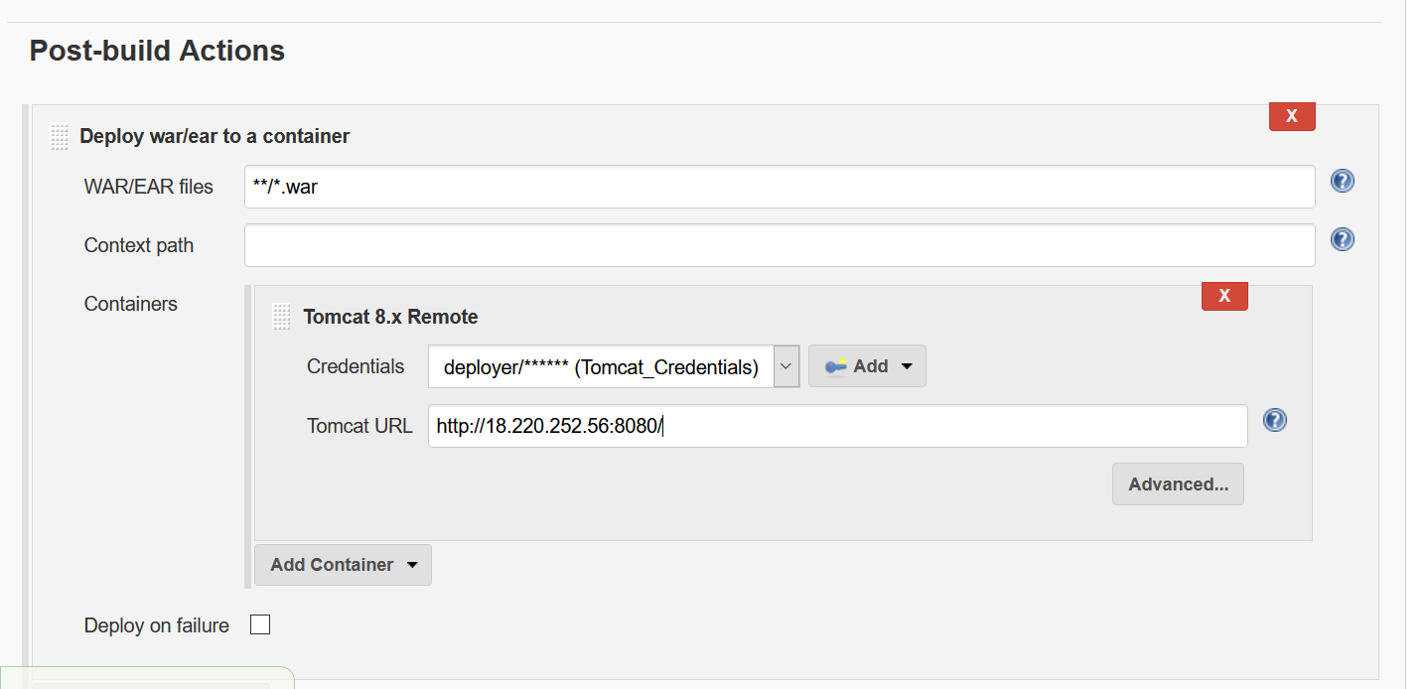

Save.

1. Run the Build,

Expected is Should:

* + - Generate the webaap.war at target folder in Jenkins server EC2 machine(CI)
    - Deploy the webaap.war from Jenkins server to Tomcat Serer(CD)

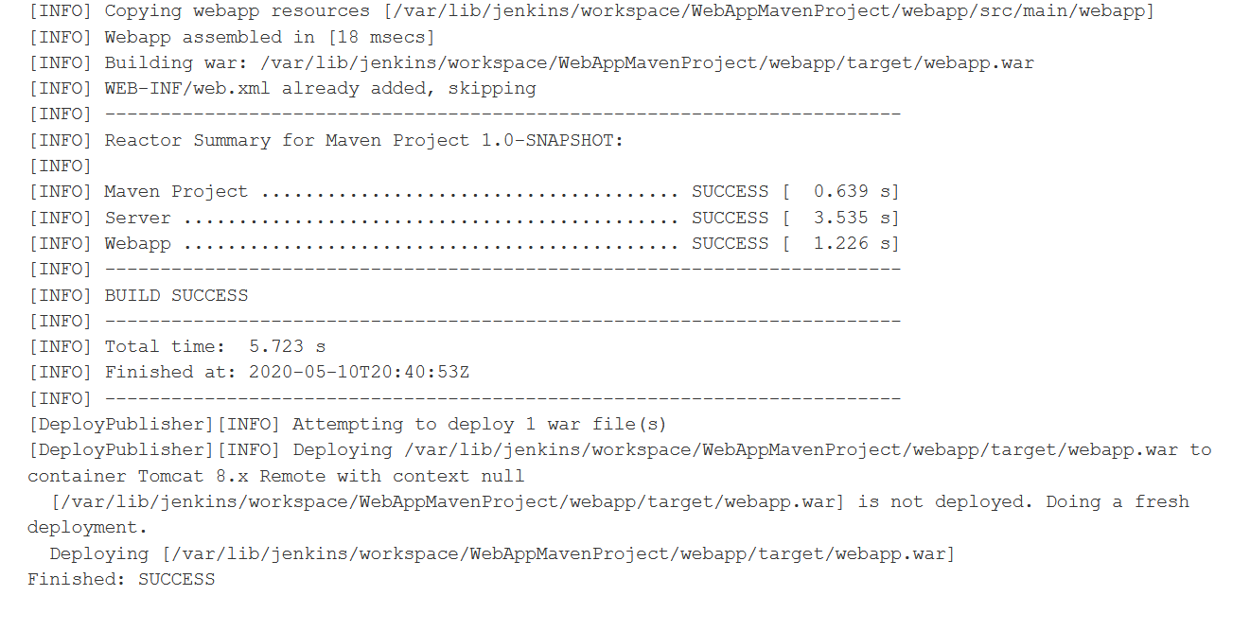

Go to Browser and hit the application URL –

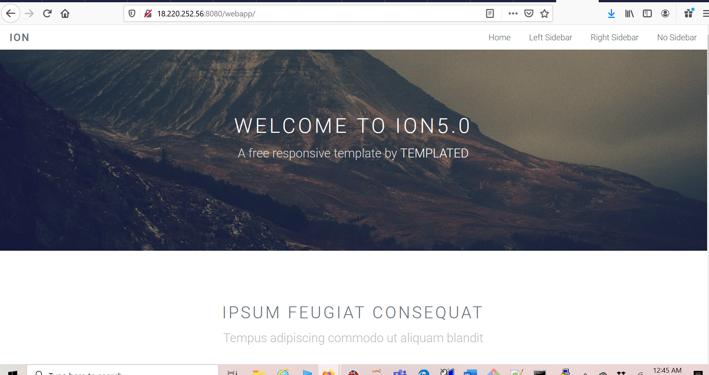

1. Schedule the Build job to run on every 2 minutes if any changes has been pushed to Git Repository.
   * + Select the Job Name -> Configure

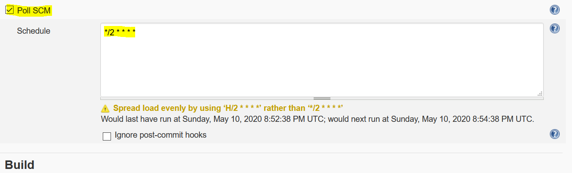

Save.

* + - Open the source code and updated the below highlighted code.

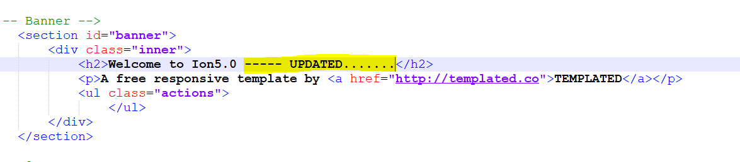

* + - Check-in and push changes to git repository, then observe the build will be trigged in Jenkins.

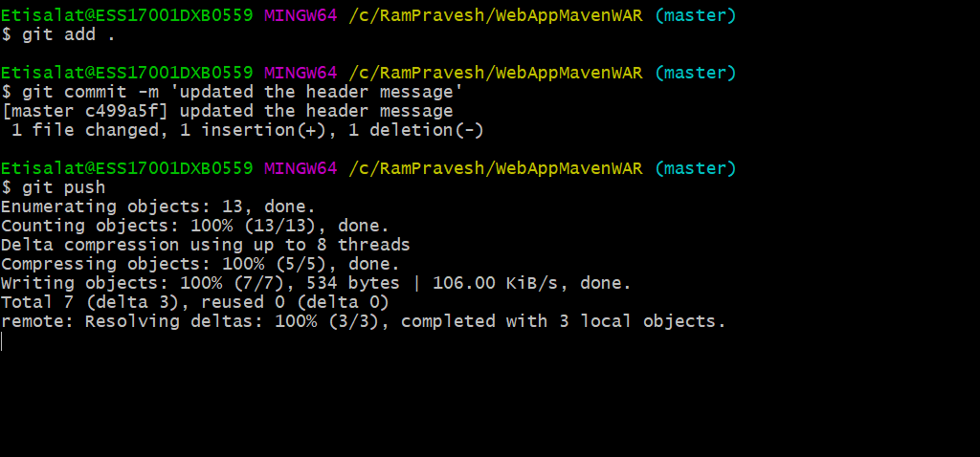

* + - We can observe that 3rd build has been generated and deployed the changes in tomcat(CD)
  1. 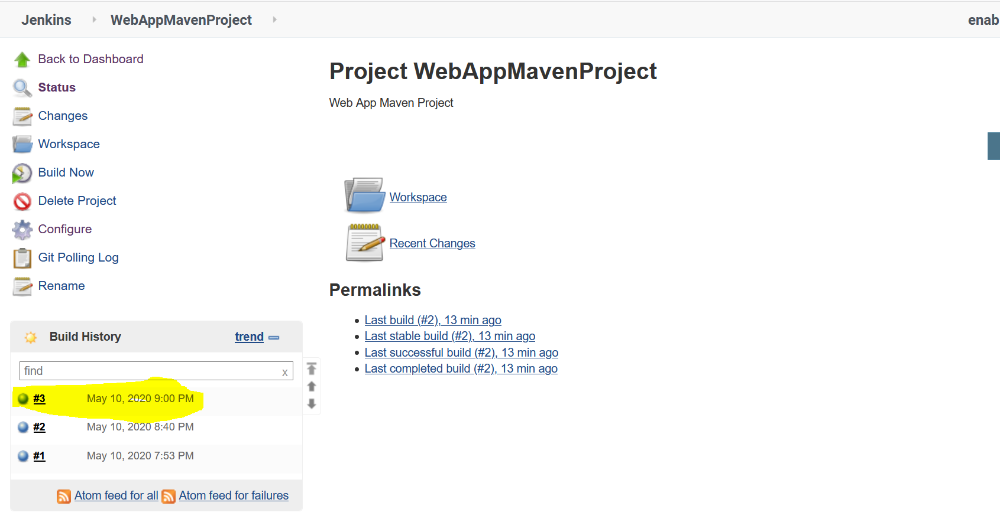

Refresh the browser and –

